**Mini Project Report**

PADMABHOOSHAN VASANTRAODADA PATIL INSTITUTE

OF TECHNOLOGY BUDHGAON (SANGLI)

DEPARTMENT OF COMPUTER SCIENCES AND ENGINEERING

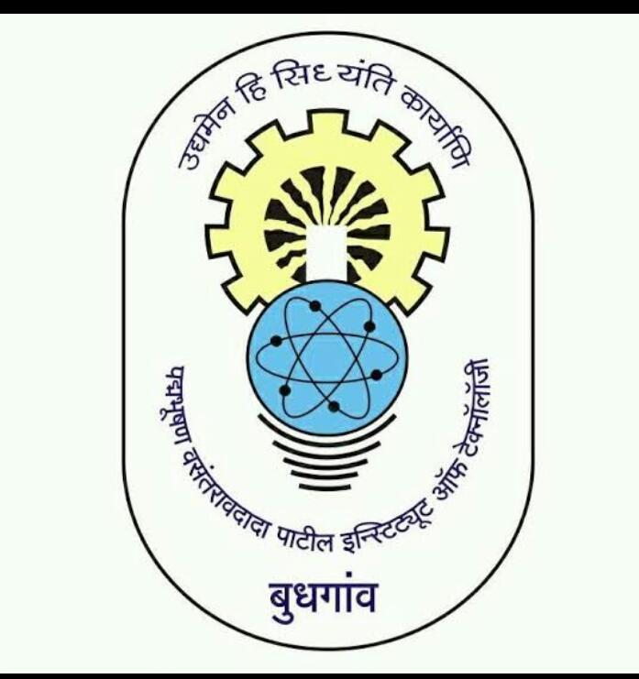

A

PROJECT REPORT

On

**“PIANO IN BASIC C PROGRAMMING”**

SUBMITTED BY

|  |  |  |
| --- | --- | --- |
| Sr.No. | Name of the Students | Roll No. |
| 01 | Mr.Vivek Ankush Bhosale | 603 |
| 02 | Mr.Chandrakant Subhash Birajdar | 604 |
| 03 | Mr.Rohit Jitendra Dol | 606 |
| 04 | Mr.Utkarsh Balu Lubal | 617 |

2018-19

DR. PADMABHOOSHAN VASANTRAODADA PATIL INSTITUTE

OF TECHNOLOGY BUDHGAON (SANGLI)-416304.

CERTIFICATE



This is to certify that the project work entitled

**“Piano In Basic C programming”**

Has been successfully completed by

Mr.Vivek Ankush Bhosale

**In the fulfillment for the**

**Degree in Information Technology**

**During the academic year: 2018-19**

**under the guidance of**

**Mrs.M.A.Khade Prof.Ranade U.U.**

(Miniproject Guide) (H.O.D.)

Prof.Dr.D.V.Ghevde

(Principal)

2018-19

DR. PADMABHOOSHAN VASANTRAODADA PATIL INSTITUTE

OF TECHNOLOGY BUDHGAON (SANGLI)-416304.

CERTIFICATE



This is to certify that the project work entitled

**“Piano In Basic C programming”**

Has been successfully completed by

Mr.Utkarsh Balu Lubal

**In the fulfillment for the**

**Degree in Information Technology**

**During the academic year: 2018-19**

**under the guidance of**

**Mrs.M.A.Khade Prof.Ranade U.U.**

(Miniproject Guide) (H.O.D.)

Prof.Dr.D.V.Ghevde

(Principal)

2018-19

DR. PADMABHOOSHAN VASANTRAODADA PATIL INSTITUTE

OF TECHNOLOGY BUDHGAON (SANGLI)-416304.

CERTIFICATE



This is to certify that the project work entitled

**“Piano In Basic C programming”**

Has been successfully completed by

Mr.Rohit Jitendra Dol

**In the fulfillment for the**

**Degree in Information Technology**

**During the academic year: 2018-19**

**under the guidance of**

**Mrs.M.A.Khade Prof.Ranade U.U.**

(Miniproject Guide) (H.O.D.)

Prof.Dr.D.V.Ghevde

(Principal)

2018-19

DR. PADMABHOOSHAN VASANTRAODADA PATIL INSTITUTE

OF TECHNOLOGY BUDHGAON (SANGLI)-416304.

CERTIFICATE



This is to certify that the project work entitled

**“Piano In Basic C programming”**

Has been successfully completed by

Mr.Vivek Ankush Bhosale

**In the fulfillment for the**

**Degree in Information Technology**

**During the academic year: 2018-19**

**under the guidance of**

**Mrs.M.A.Khade Prof.Ranade U.U.**

(Miniproject Guide) (H.O.D.)

**Prof.Dr.D.V.Ghevde**

(Principal)

2018-19

**Acknowledgement**

* During the selection of “**Piano In Basic C Programming**” help we received from our professor, friends is valuable and we are forever thankful to them.
* We would first like to express our gratitude to our project guide Mrs.M A Khade and Mrs.U U Ranade.
* For their immense support, suggestion, encouragement and interest in our project work. Without their valuable suggestion our project would be incomplete.
* We would like to thank our friends and group members for their belief and patience in our struggle.

Date:-29/04/2019

Place:-Budhgaon

2018-19

**INDEX**

|  |  |  |  |  |
| --- | --- | --- | --- | --- |
| **Sr.No.** | **Content** | | | **Page No.** |
| **1.** | Introduction. | | | 01 |
| **2.** | Design. | | | 02 |
|  | 2.1 | | Software Requirement. | 03 |
|  | 2.2 | | Hardware Requirement. | 03 |
| **3.** | System Architecture. | | | 04 |
|  | 3.1 | Data Flow Chart. | | 05 |
| **4.** | Model Description. | | | 06 |
| **5.** | Snapshot. | | | 08 |
| **6.** | Conclusion. | | | 14 |
| **7.** | Reference. | | | 15 |